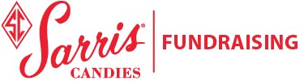

Support the Practical Nursing Scholarship Funds by purchasing
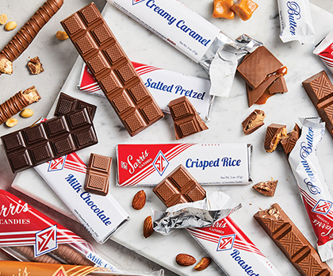
Candy Bars and Pretzel Rods just $2 each!

